HEIA TASMANIA 2019 Sustainable Living GALA

Invoice/Registration form
When: Saturday March 30th 9.00 – 3 pm
Where: Clarence High School, Bellerive, Hobart
Choose 2 workshops + Lunch included
Name:
School:
Email address:

Highlight or circle the area you teach in:

Home Economics Textile Design and Technology
Kitchen Garden Interested teacher

Number of tickets:
Cost to members: $30 Cost to non- members: $60
RSVP: 16 March 2019 - jcreed8@bigpond.com

Payment BANK DEPOSIT: MyState, BSB 807009, Account No 12162211
Account name HEIA Tas. Please include your surname as the reference

Workshop 1: 10 am - 11am - Choose one of the following

Recycle bags O Bao Buns O 3D Printer in the Classroom O
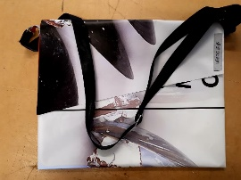

Workshop 2: 12 pm – 1 pm Choose one of the following

Beeswax wraps O Planetary diet O Eat Wild Tasmanian

